GRANBY WINTER GARDEN
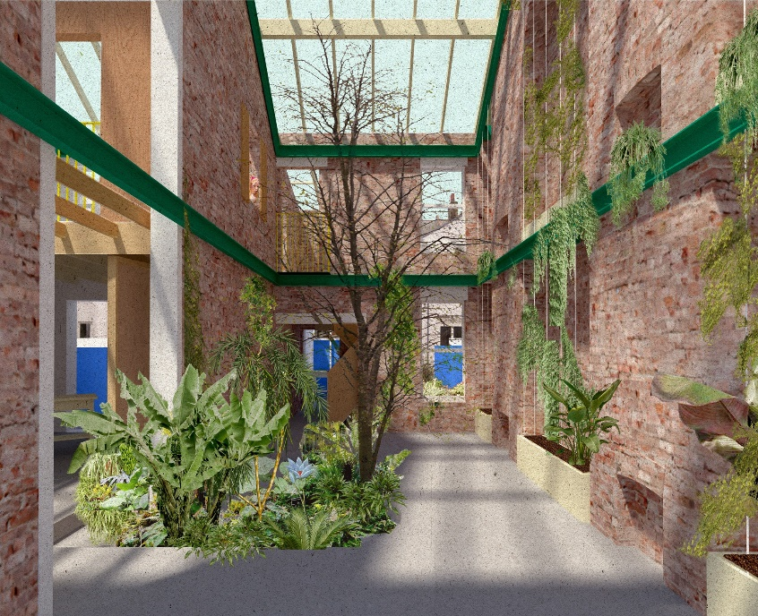
Planting mock-up

COMMUNITY GARDENER IN RESIDENCE

Post: Community Gardener in Residence
Wage: 6-month contract initially. £16.00 per hour. Minimum of 14 hours a week
Based at: Granby Winter Garden 37-39 Cairns Street, L8 2UW
Accountable to: Winter Garden Development Group & Granby Four Streets Community
Land Trust
Start date: June 2018 to December 2018
Probation: This post carries a 2-month probationary period.
Deadline for applications: Monday 21st May, 4p.m.

GRANBY WINTER GARDEN PROJECT
Two Victorian 2-bedroomed terraced houses in the heart of Granby have been re-imagined and re-built as extraordinary sustainable, multi-purpose spaces, owned and managed by and for the local community. One house is opened up to the full height of the building, with a glass roof, becoming a public indoor garden full of greenery, with trees, ferns and climbers using the whole space. The second will combine an artist’s residency & workshop, a community meeting, making and socialising space and an Air bnb.

Granby Community Land Trust Winter Garden Project

INTRODUCTION
Granby Winter Garden is a collaboration between Assemble, Granby Four Streets Community Land Trust and local residents, it is based in the heart of Liverpool 8 and is a key project in the CLT’s long-term plans to revitalise the Granby neighbourhood. The Community Land Trust (CLT) is a non-profit community-based organisation that is creating affordable homes and enabling regeneration in the Granby Four Streets area. Our members are made up of local residents in Granby and local community organisations and businesses.

GRANBY – THE CENTRALITY OF PEOPLE AND PLACE
Granby Street was once a lively, cosmopolitan high street which was the historic focus of the black community in Liverpool. 10 minutes from the city centre and right by two of Liverpool’s loveliest parks, it is an architecturally, socially and culturally rich environment – a really lovely neighbourhood. It was also at the centre of the Toxteth uprising of 1981 - having experienced generations of poverty, unemployment, and institutional racism.
Over the last 30 years, hundreds of terraced houses have been compulsory purchased, boarded up & demolished - and a long-standing community dispersed. The CLT grew out of the community’s long and varied campaigns to oppose demolition and rebuild their neighbourhood. These included Granby Residents’ Association and collective direct actions: public art works, a street market and most visibly, the guerrilla gardening that residents have carried out over the past decade.
The only four remaining original streets are now undergoing a major refurbishment programme by a mix of partners. It’s a time of change and of rebuilding: of our shops, community resources, youth and employment opportunities, and of our own daily interactions with our each other and our built environment.
Granby is a resilient community, but it still has to be viewed in the context of harsh and confining socio-economic realities. It seems clear that these external conditions will not improve – and one of the key lessons that we have learnt over the last decades is that we have to organise to take control of our neighbourhoods. Our best options lie in community ownership, collective hands-on activities and the willingness to think and act outside the box.

THE STREETS ARE THE GARDEN
Community Gardener - Gardener in Residence
We aim to create, by our own work and imagination, the greenest quarter in the city - streets and public spaces that are green, creative places for people of all ages to plant, meet, socialise and play in.
The Winter Garden project bridges separations between indoors and outdoors, personal and public space. Our streets are galleries, gardens, playground and meeting places. Experience over the last 10 years has shown us that gardening can be a transformative act, with the potential to regenerate an apparently ‘doomed’ neighbourhood by changing the appearance, atmosphere and ‘liveability’ of our streets. It gives a sense of common purpose and of creative control over our environment.
We want to make the most of those who already have horticultural skills and knowledge in Granby - working with individuals and organisations to support and share their expertise - as well as to create new opportunities for those with less experience.
We believe that gardening is an inherently creative activity with the potential to benefit people from all walks of life. We are looking for someone who shares this outlook.

Gardener in Residence ‘The Street is the Garden.’

Job Description
We are looking for a driven and experienced candidate with a keen interest in community development through gardening and creative practices, particularly in public spaces. The ideal candidate for this position will have good practical horticultural knowledge as well as having creative vision.

Key tasks
- The Winter Garden
- To make the Winter Garden a space where all members of our diverse community have a sense of ownership, ease and belonging and which is warm and welcoming to visitors.
- Support the design and initial planting up of the indoor garden
- The Gardener in Residence will be in charge of managing and maintaining the indoor garden area, working with volunteers to:
- Provide plant care, watering, feeding, pruning, pest control
- monitor conditions – humidity, temperature, soil
- maintain tools and equipment storage

- Public Spaces
- Identify and assist the development of other community landscaping and growing opportunities within the area – in particular the use of derelict, unused or underused spaces.

- Volunteers and Activities
- Co-ordinate the work of volunteers: both those who already have considerable horticultural skills and knowledge, as well as creating new opportunities for those with less experience.
- Organise and co-ordinate and run free open-access practical and creative workshops, events and skill shares that are relevant to residents.

- Strengthening community skills, self-reliance and sustainability
- Explore some mentoring /training opportunities for local horticulturalists who might want to widen their areas of expertise. Our aims are to build on and extend local experience and expertise leading to the long-term self-reliance and sustainability and expansion of this project within the wider neighbourhood.

- Co-operative Work with local Community Organisations
- Work with existing community-based horticultural organisations to support and expand their activities.
- Engage with other local community organisations – particularly those working with young people, to initiate or expand horticultural projects.

- Local focus – global reach
We are keen to make connections and learn from innovative ideas and inspiration nationally and internationally and to strengthen connections we have started to make with ‘The Eden Project’, Botanic Garden in Edinburgh and Ness Gardens.

REQUIREMENTS - ESSENTIAL

- A proven practical horticultural knowledge
- A proven record of delivering creative projects
- Experience of running a project and/or making things happen within a community setting
- Experience of working in a diverse community and understanding of the impact of racism
- The ability to relate and work well with people from all walks of life
- Proven track record of work with and management of volunteers
- Excellent facilitation skills that can support participatory processes
- Self-motivated with strong organisational skills, the ability to demonstrate initiative and to work to deadlines
- Good administrative skills to report on activities
- Willingness to occasional work outside normal working hours as required by the project

DESIRABLE ATTRIBUTES

- Experience of planting, indoor and landscaping in urban public spaces
- Knowledge and understanding of community learning and development
- Driving license
- Ability to speak Arabic or Somali.

APPLICATION PROCESS
Applications should include:
● A covering letter not exceeding 1 A4 page (point 11 text) stating why you wish to be considered for this position
● A completed application form.
Please send your email application to Granby4streetsclt@gmail.com, or hard copies to John McGuigan, North West Housing Services, 19, Devonshire Road, Liverpool L8 3TX, with the subject heading ‘Gardener in Residence Application/YOUR NAME’
● Closing Date: Monday, May 21st at 4 p.m.
● Shortlisted candidates will be informed by Wednesday May 23rd
● Interviews will take place on Friday, May 25th

http://www.granby4streetsclt.co.uk

